**Lesson05 Generalization in Azure VM**

**Notes: -**

**1-with generalization we can create image resource from the Azure VM and used to create many Azure VM’S as below**

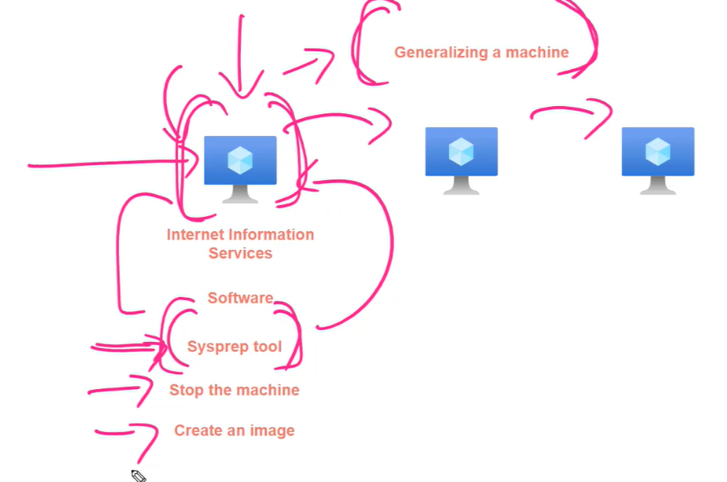

**Steps: -**

**1-on Azure > crate virtual machine we set the azure subscription and resource groups as below** 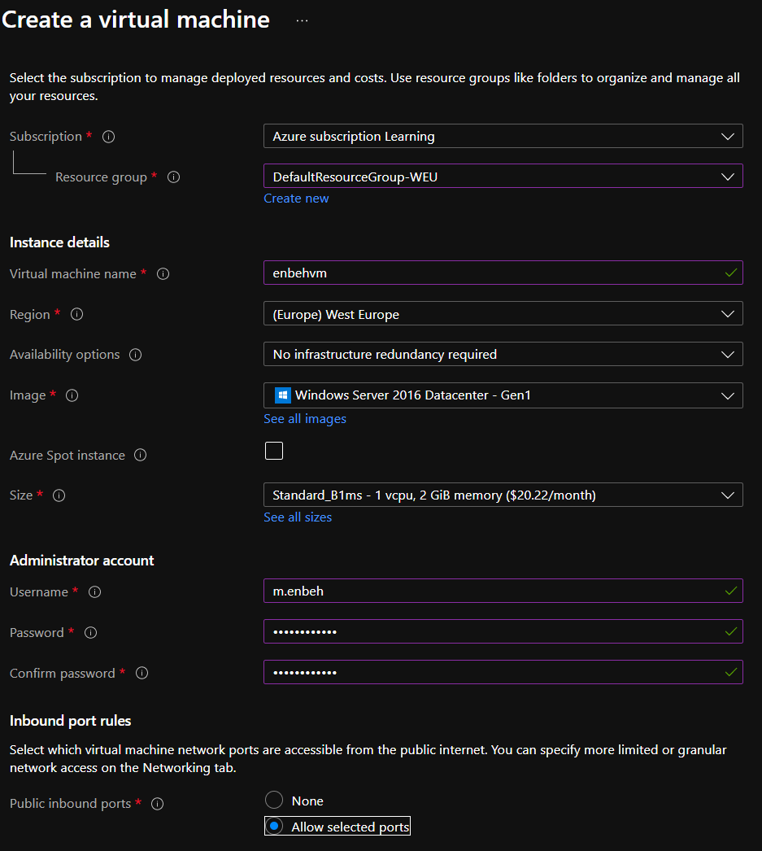

**2-we make static IP address with set the domain name as below**

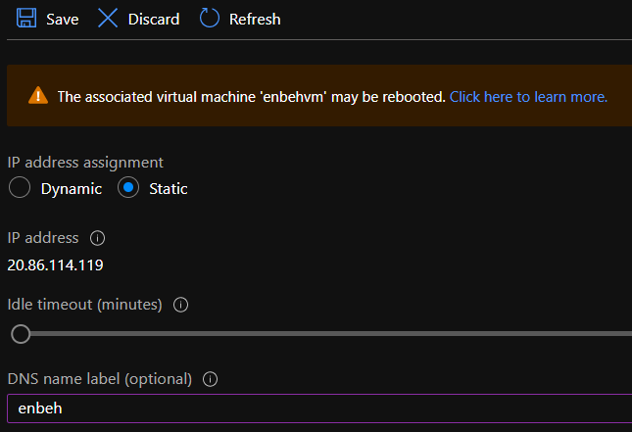

**3-we will add two networking roles as below**

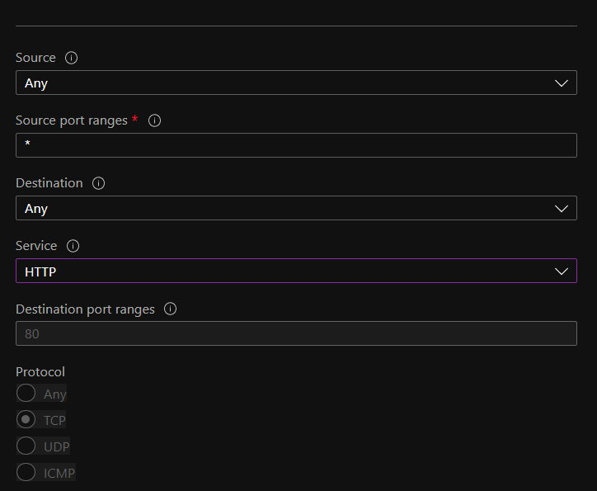

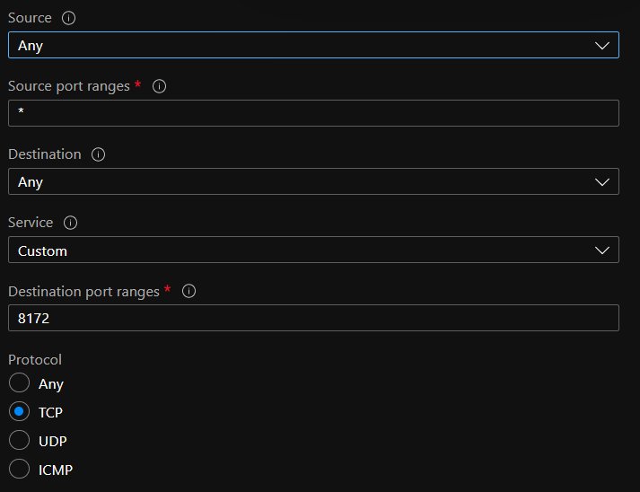

**4-on Azure VM > server manager > add roles and features > we add the web server IIS**

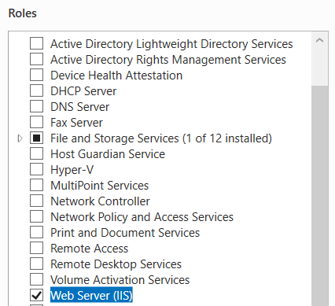

**We select the management service on the roles services before confirm and then click ok**

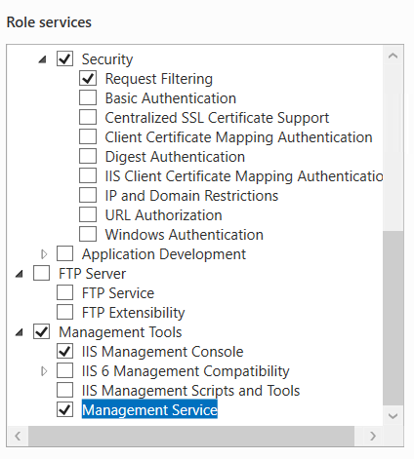

**5-on Azure VM > server manager > Local server > set IE enhanced security configuration (turn off settings)**

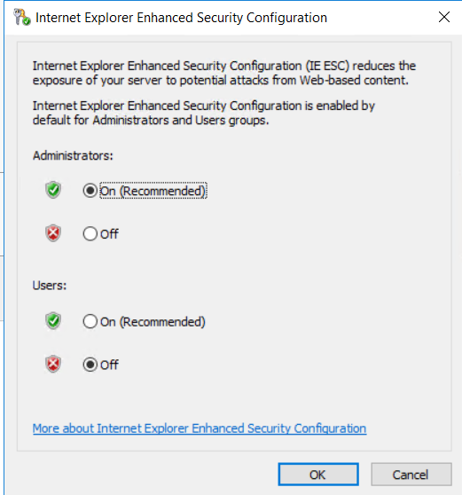

**6-we install the 2 following apps as below:-**

**https://dotnet.microsoft.com/download/dotnet/thank-you/runtime-aspnetcore-3.1.16-windows-hosting-bundle-installer**

**A-.Net Core 3.1 runtime**

**B-Web platform installer from IIS**

**C-Web platform installer > Web Deploy 3.6**

**7-on IIS > enbehvm > management service**

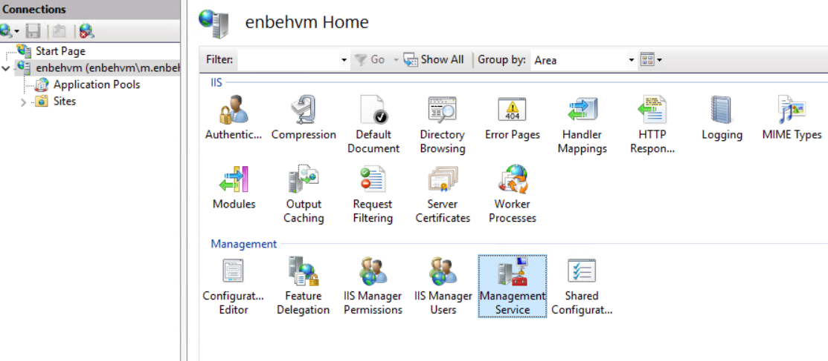

**8-Enable remoter connection with click apply and start button**

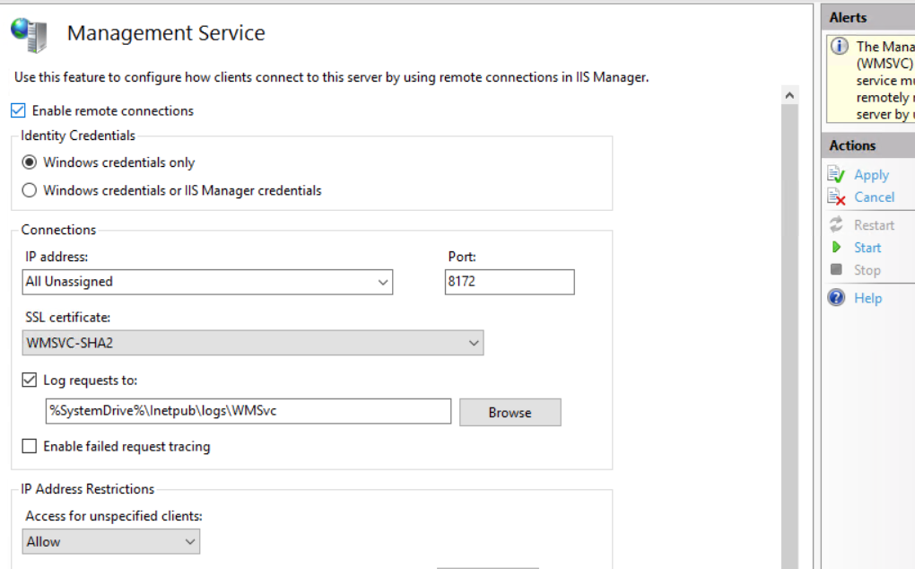

**9-on service > web management service > properties > automatic > start**

**10-create .net core 3.1 project > publish > Azure virtual machine > we set the publish > configure > we set username and password and validate connection and click OK**

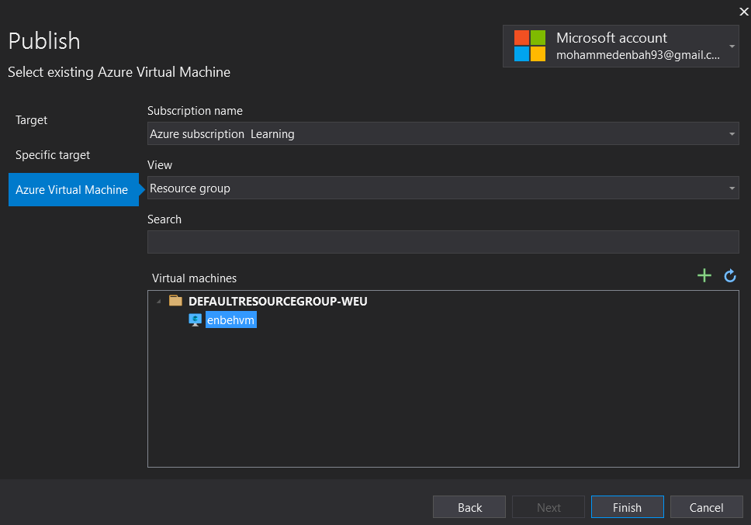

**New Part: -**

**11-on Azure VM > start > type %windir%\system32\sysprep > click on sysprep and choose and check Generalize options checkbox**

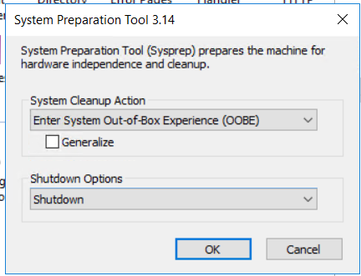

**(it will shut down OS level not the Azure VM)**

**12-on Azure VM > Click Capture button to create new Azure resource image as below**

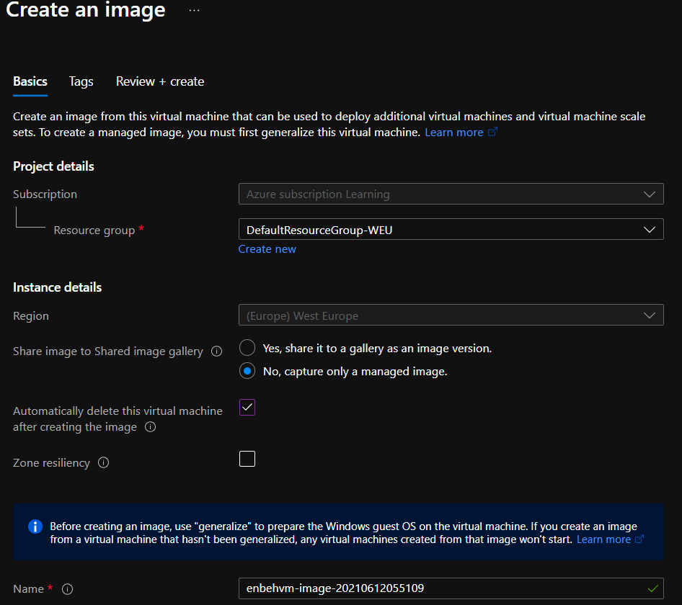

**(It will create new azure image that will used on create virtual machine as below)**

**13-on azure > enbehvm-image > we create VM from the created image as below**

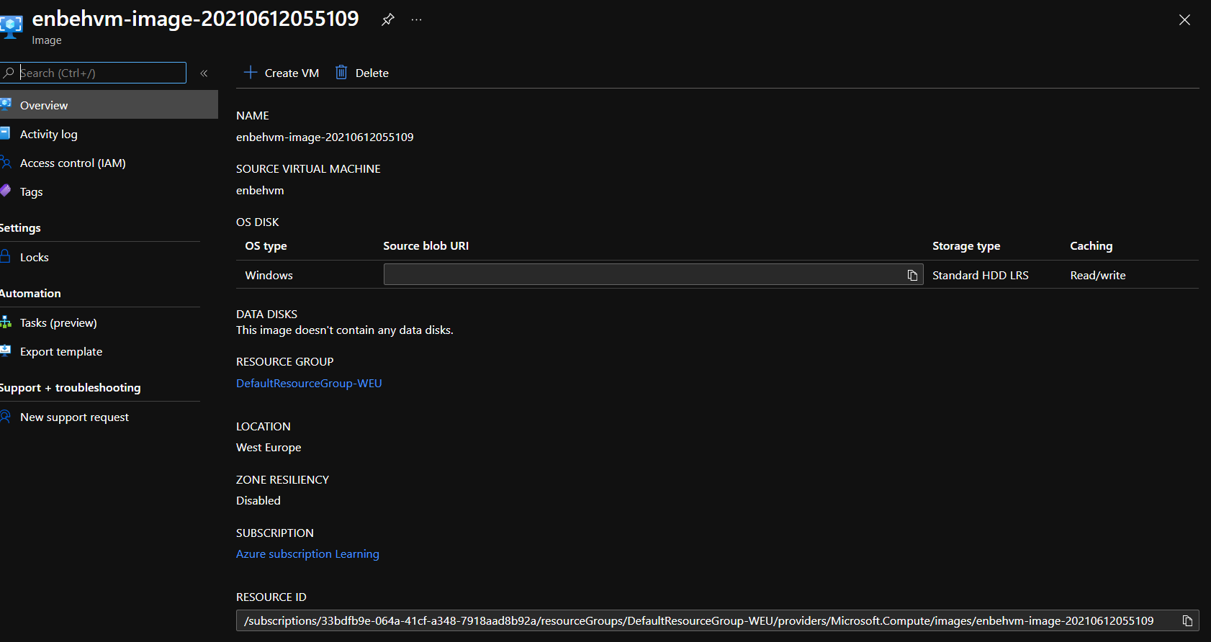

**14-you have to set the networking inbound rules 80 , 8172 on Azure VM**

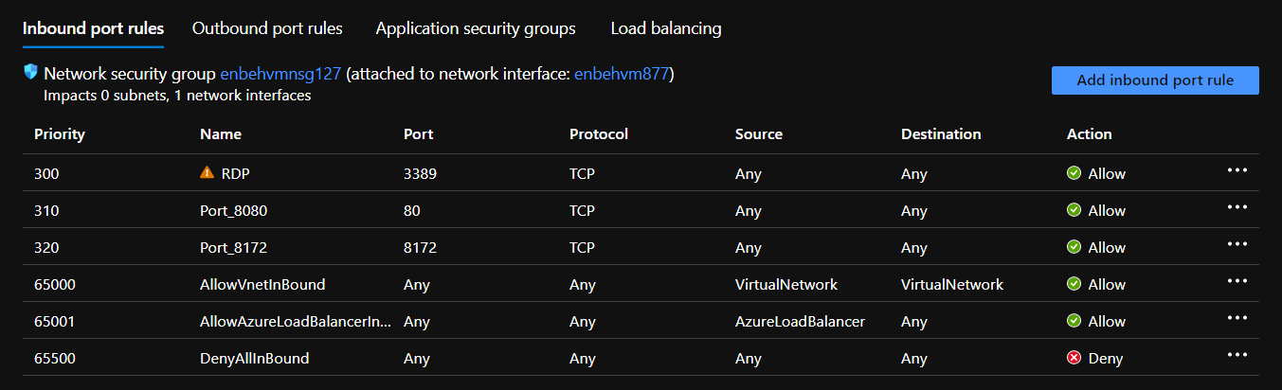

**15-we have to configure DNS name on Azure VM and set static IP address**